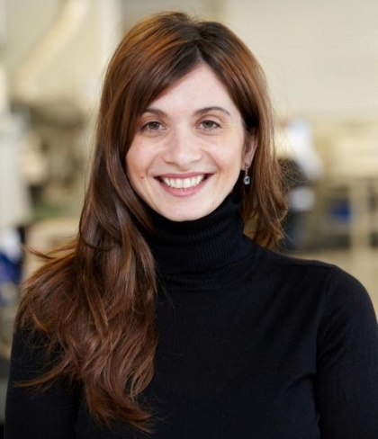
Dr Francese holds a degree in Chemistry and a PhD in Chemical Sciences. She is an expert in the development of Matrix Assisted Laser Desorption Ionisation Mass Spectrometry Imaging (MALDI MSI) applications and has pioneered its development for the analysis of latent fingermarks to extract additional intelligence profiling the crime and the offender. At Sheffield Hallam University, UK, she was appointed Lecturer (2008), Senior Lecturer (2011) and Reader (2014) and initiated forensic research at this Institution. Leader of the Fingermark Research Group, her research is partly funded by the Home Office, CAST. She is one of the 40 members of the International Fingermark Research Group selected from across the world of the European Network of Forensic Institutes (ENFSI) and is a core team member of the Centre of Excellence in Terrorism, Resilience, Intelligence & Organised Crime Research (CENTRIC). Dr Francese actively collaborates with West Yorkshire Police (UK) to test the technology at crime scenes.

