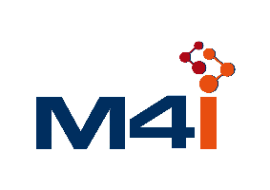

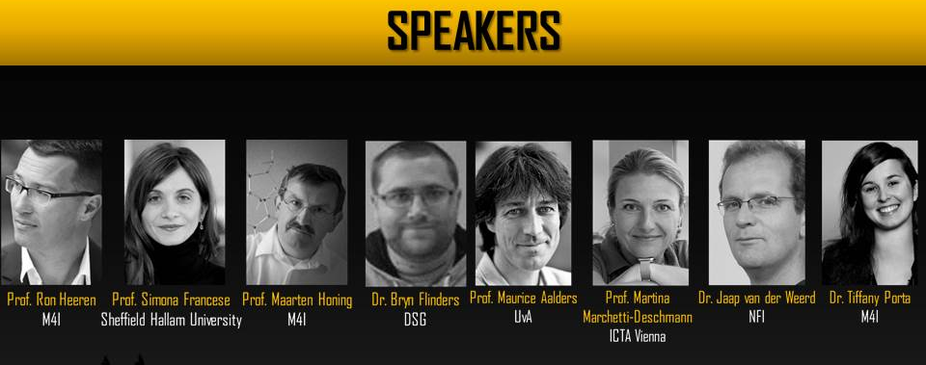
COST CA16101 II Training school – Dec. 10th – 13th, 2018 - Maastricht
Molecular Imaging Forensics Training School
Application form
Name…………………………….…………………..Surname……………………………………………………
Institution/Industry/End User name…………..………………………………………………………….
Country………………………………....................................................................................

Early career investigator*: YES NO

According to COST definitions, ECI are individuals whose career spun less than 8 years between the date of the PhD/doctorate (or similar experience) and the date of involvement in the COST Action. Periods of career leave have to be added to this time span.

Expertise: ………………………………………………………………………………………………………………………………………………………………………………………………………………………………………………………………………………………………………………………………………………………………………………………………………………………………………………………………………………………………………………

Qualifications:
……………………………………………………………………………………………………………………………………………………………………………………………………………………………………………………………………………………………………………………………………………………………………………………………………………………………………………………………………………………………………………………………...…………………………………………………………………………………………………………………………………………………………………………………………………………………………………………………………...…………………………………………………………………………………………………………………………………………………………………………………………………………………………………………………………………

Reasons for applying:
……………………………………………………………………………………………………………………………………………………………………………………………………………………………………………………………………………………………………………………………………………………………………………………………………………………………………………………………………………………………………………………………...
……………………………………………………………………………………………………………………………………………………………………………………………………………………………………………………………………………………………………………………………………………………………………………………………………………………………………………………………………………………………………………………………...

For PhD students only - please have the below completed by your supervisor
Additional documents
- CV
- For PhD students only - Attach a reference letter from your Supervisor (on headed paper and signed)

Please send the application form and the requested documents , NO LATER than October 18th to:
Prof. Simona Francese, CA16101 Action Chair - s.francese@shu.ac.uk

- Applications will be reviewed by 3 members of the Core group
- Results will be communicated to the applicant, no later than October 30th

